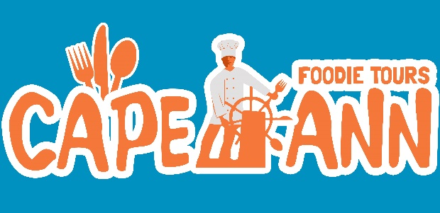
TASTE GLOUCESTER TOUR SUMMARY
- Walking Tour lasting 2.5 hours and covering less than a mile
- Native Gloucester guide brings historical knowledge and local color to the experience
- Six Food Stops highlighting restaurants and culinary experiences
- Samples included with a focus on their specialty
- Price is $55 and includes all food (and there is plenty), tour guide services, and gratuities for wait staff.
- 5***** TripAdvisor rating with 100+ rave reviews!

What is a food tour people may wonder? It is a different way of seeing a city. Ours is a food-focused walking tour (we travel about a mile) and it's approximately 2.5 hours long. Folks walk away with local knowledge and a full belly.
The tour begins at Harbor Loop where our guide gives a history of Cape Ann. Guides are informative and fun! And they carry a large fork which gets lots of attention during the tour and makes for entertaining and memorable photos.
We walk up Rogers Street towards Main and visit the Topside Grill. Here we have award-winning clam chowder and scallops wrapped in bacon with a honey mustard glaze; SO good.
Next, it’s the Cape Ann Olive Oil Company. Here there is a presentation and guests sample olive oils and balsamic vinegars from all over the world.
Onto Virgilio’s Italian Bakery. This family-owned business (beginning in 1961) makes their own bread every morning. We sample the famous Saint Joseph's sandwich, which consists of delicious Italian cold cuts, olive oil and oregano on their fresh roll.
Guests and their guide cross the street for a mini-cannoli at the quaint Italian cafe Café Sicilia, a real locals’ hangout. Guests can choose from plain, chocolate chip, pistachio, or almond.
It's a short walk to St Peter’s Square where – of course – we visit the Cape Ann Brew Pub. Here while enjoying a great harbor view with active fishing boats and lobster traps galore, guests choose two beer samples and are treated to a haddock plate with homemade fries and cole slaw.
Last stop is Turtle Alley. Ending on a sweet note, guests savor a choice of a large turtle, two caramels, or a peanut butter cup all made fresh daily.

For reservations visit: www.capeannfoodietours.com or call 617-902-8291

